Android Layouts
Parent means frame/window
Child means components like ( TextView, EditText, Button etc)
View is base class of all UI elements.
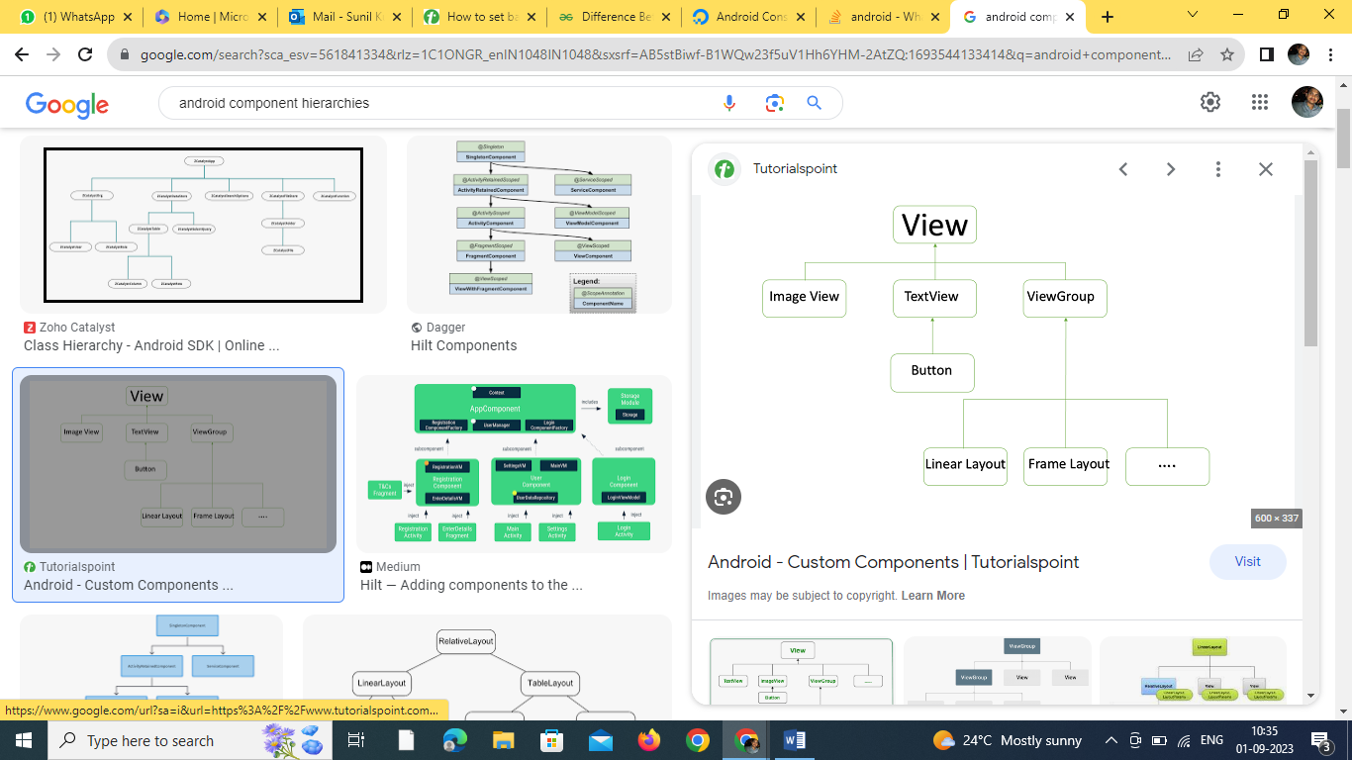
Widget - refer to a 'ready to use' UI element, be it a Button, ImageView, EditText, etc

ConstraintLayout/absolute layout/ No Layout
Drag/Drop feature works well
It is used to define a layout by assigning constraints for every child view/widget relative to other views present. A constraintLayout is similar to RelativeLayout , but with more power. The aim of ConstraintLayout is to improve the performance of the applications by removing the nested views with a flat and flexible design.
A view inside the ConstraintLayout has anchor points/handles on each side which are used to assign the constraints.
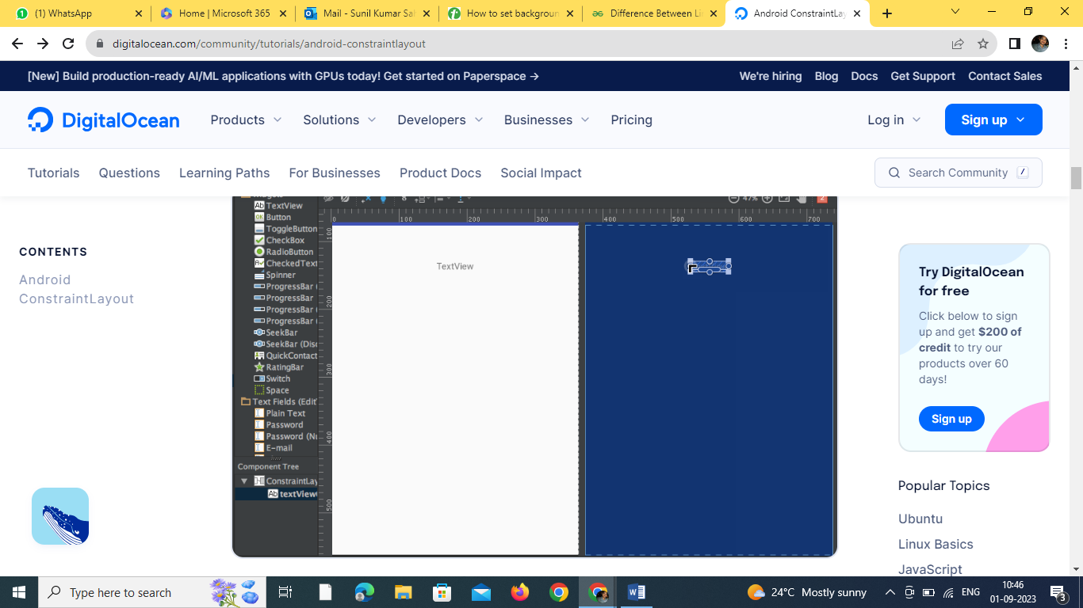

The TextView above has three types of handles:
Resize handle - It’s present on the four corners and is used to resize the view, but keeping its constraints intact.
Side handle - It’s the circular handle present on the centre of each side. It’s used to set the top, left, bottom and right constraints of the view.
Baseline handle - It’s used to align the baseline with another textview in the layout.
Let’s assign the constraints on the TextView and look into the xml code of it.


https://journaldev.nyc3.digitaloceanspaces.com/2017/01/android-constraint-layout-textview-2.gif
Notice the Properties inspector pane at the right-hand side: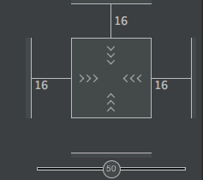
It shows the margins set for each side of the view. It also allows to change the size of the view by toggling between the following modes:
- Wrap Content - This wraps the view to fill it’s content.
- Any Size - This is similar to match parent.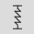
- Fixed Size - This allows us to set constant width and height.
The xml code for the above layout looks like: sample.xml
<?xml version="1.0" encoding="utf-8"?>
<android.support.constraint.ConstraintLayout
xmlns:android="https://schemas.android.com/apk/res/android"
xmlns:app="https://schemas.android.com/apk/res-auto"
android:layout_width="match_parent"
android:layout_height="match_parent">

<TextView
android:text="TextView"
android:layout_width="wrap_content"
android:layout_height="wrap_content"
android:id="@+id/textView"
android:layout_marginStart="16dp"
android:layout_marginTop="16dp"
app:layout_constraintLeft_toLeftOf="parent"
app:layout_constraintTop_toTopOf="parent"
android:layout_marginLeft="16dp"
android:layout_marginEnd="16dp"
app:layout_constraintRight_toRightOf="parent"
android:layout_marginRight="16dp" />
</android.support.constraint.ConstraintLayout>

Here parent means the layout itself.
- app:layout_constraintLeft_toLeftOf="parent" - constraintLeft is the anchor point to the left of the view. toLeftOf signifies aligning the view to the left of the assigned view which is “parent” in this case. When the absolute positions are set on the view, the xml properties that are used are -
tools:layout_editor_absoluteY="48dp"
tools:layout_editor_absoluteX="40dp"

Let’s add another TextView and align their baselines.


The xml code for the above layout is :
<?xml version="1.0" encoding="utf-8"?>
<android.support.constraint.ConstraintLayout
xmlns:android="https://schemas.android.com/apk/res/android"
xmlns:app="https://schemas.android.com/apk/res-auto"
xmlns:tools="https://schemas.android.com/tools"
android:layout_width="match_parent"
android:layout_height="match_parent">

<TextView
android:text="TextView"
android:layout_width="wrap_content"
android:layout_height="wrap_content"
android:id="@+id/textView"
android:layout_marginStart="16dp"
app:layout_constraintLeft_toLeftOf="parent"
android:layout_marginLeft="16dp"
android:layout_marginEnd="16dp"
app:layout_constraintRight_toRightOf="parent"
android:layout_marginRight="16dp"
android:layout_marginTop="16dp"
app:layout_constraintTop_toTopOf="parent" />

<TextView
android:text="TextView"
android:layout_width="wrap_content"
android:layout_height="wrap_content"
android:id="@+id/textView2"
app:layout_constraintBaseline_toBaselineOf="@+id/textView"
android:layout_marginStart="16dp"
app:layout_constraintLeft_toLeftOf="parent"
android:layout_marginLeft="16dp"
app:layout_constraintRight_toLeftOf="@+id/textView"
android:layout_marginEnd="8dp"
android:layout_marginRight="8dp" />

</android.support.constraint.ConstraintLayout>

There are two other tools Auto-connect and Inferences that are used to created constraints automatically.
- Auto-Connect - This feature can be enabled by clicking:As the name suggests, Auto-connect creates constraints automatically between two neighbouring views
- Inference - This feature is enabled by clicking:The Inference engine creates constraints among all elements in a layout. The inference engine tries to find and create optimal connections based on various factors such as the positions of the widgets and their size.
A demo of Auto-Connect layout is given below:As you can see in the above gif, The constraints are animated automatically. Notice the horizontal and vertical sliders in the properties pane. They are called horizontal and vertical bias respectively. They allow us to position a view along the horizontal or vertical axis using a bias value, this will be relative to it’s constrained position. The xml code for the above demo is given below:
<?xml version="1.0" encoding="utf-8"?>
<android.support.constraint.ConstraintLayout
xmlns:android="https://schemas.android.com/apk/res/android"
xmlns:app="https://schemas.android.com/apk/res-auto"
xmlns:tools="https://schemas.android.com/tools"
android:layout_width="match_parent"
android:layout_height="match_parent">

<ImageView
android:layout_width="wrap_content"
android:layout_height="wrap_content"
app:srcCompat="@mipmap/ic_launcher"
android:id="@+id/imageView7"
app:layout_constraintBottom_toBottomOf="parent"
app:layout_constraintRight_toRightOf="parent"
app:layout_constraintLeft_toLeftOf="parent"
app:layout_constraintTop_toTopOf="parent"
app:layout_constraintVertical_bias="0.58000004"
app:layout_constraintHorizontal_bias="0.47" />
</android.support.constraint.ConstraintLayout>
Demo of a layout with Inference enabled is given below:The xml code for the above gif is :
<?xml version="1.0" encoding="utf-8"?>
<android.support.constraint.ConstraintLayout
xmlns:android="https://schemas.android.com/apk/res/android"
xmlns:app="https://schemas.android.com/apk/res-auto"
xmlns:tools="https://schemas.android.com/tools"
android:layout_width="match_parent"
android:layout_height="match_parent">

<TextView
android:text="TextView"
android:layout_width="wrap_content"
android:layout_height="wrap_content"
android:id="@+id/textView22"
tools:layout_constraintRight_creator="1"
tools:layout_constraintBottom_creator="1"
app:layout_constraintBottom_toTopOf="@+id/button2"
app:layout_constraintRight_toRightOf="parent"
tools:layout_constraintLeft_creator="1"
android:layout_marginBottom="59dp"
app:layout_constraintLeft_toLeftOf="parent" />

<Button
android:text="Button"
android:layout_width="wrap_content"
android:layout_height="wrap_content"
android:id="@+id/button2"
tools:layout_constraintTop_creator="1"
tools:layout_constraintRight_creator="1"
android:layout_marginEnd="31dp"
app:layout_constraintRight_toRightOf="@+id/textView22"
android:layout_marginTop="178dp"
app:layout_constraintTop_toTopOf="parent"
android:layout_marginRight="31dp" />
</android.support.constraint.ConstraintLayout>
tools:layout_constraintTop_creator="1": The creator attributes to keep track of who created the constraints, particularly if they are created by the inference engine they’re assigned as 1.

Deleting Constraints
To delete an individual constraint, hover over the circular handle and click it has it turns red. To delete all constraints of a view, click the symbol underneath it that looks like:A sample demo gif is given below:

Relative Layout :

RelativeLayout is a layout in which we can arrange views/widgets according to the position of other views/widgets. It is independent of horizontal and vertical view and we can arrange it according to one’s satisfaction.

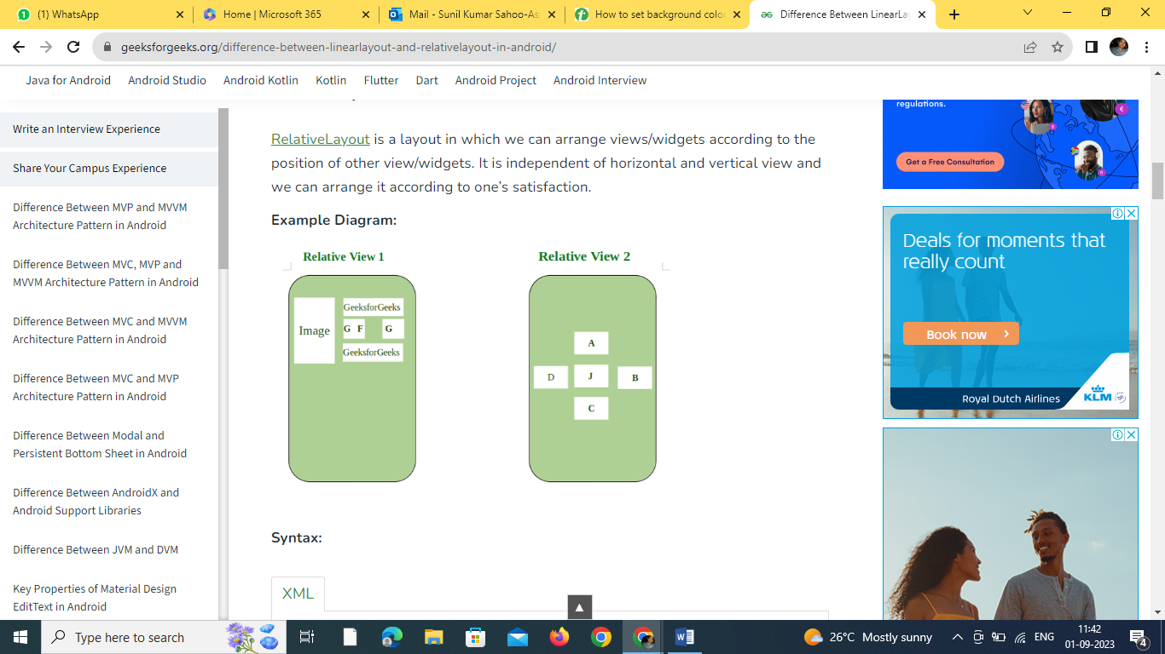

<RelativeLayout
android:layout_width="wrap_content"
android:layout_height="wrap_content">

<!--ImageView, TextView, ButtonView
etc with specified position-->

</RelativeLayout>

Linear Layout :
LinearLayout is a type of view group which is responsible for holding views in it either Horizontally or vertically. It is a type of Layout where one can arrange groups either Horizontally or Vertically.
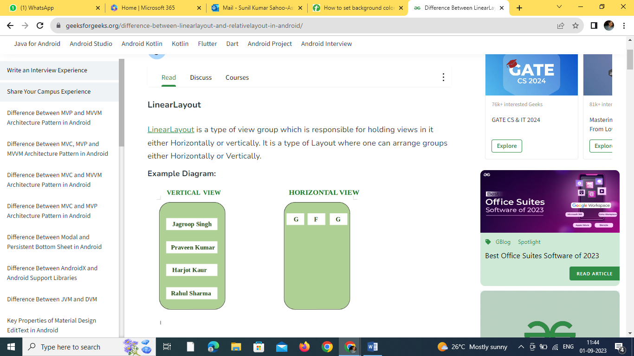

<LinearLayout
android:layout_width="wrap_content"
android:layout_height="wrap_content"
android:orientation="either vertical or horizontal">

<!--ImageView, TextView, ButtonView etc.-->

</LinearLayout>

Difference Between LinearLayout and RelativeLayout
LinearLayout | RelativeLayout
We can adjust views and widgets linearly i.e Horizontally and vertically. | We can adjust views and widgets according to one’s satisfaction.
layout_weight attribute in the linear layout is used to specify the equal or specific size to the particular widget and view by using the following attribute  android:layout_weight = ‘0’  Here Weight is specified as 0 in order to give equal size or space to each view or widget. | Various attributes like: layout_toRightOf, layout_toLeftOf, layout_below, layout_alignParentTop, layout_top, layout_alignParentLeft, layout_alignParentRight are used to specify the position of each view and widget.
It is useful when we arrange views in a linear fashion. | It is useful when we arrange views in relative fashion.
Syntax:  <LinearLayout>  <!–Views, widgets–>  </LinearLayout> | Syntax:  <RelativeLayout>  <!–Views, Widgets–>  </RelativeLayout>
Example: In various Apps, LinearLayout is mainly applicable in the SignUp screen where Name, Email, Phone Number, Submit, etc. are arranged in a linear fashion. | Example: In Google Play Store, when we open the app, the games, books, movies, and App’s sections all are arranges in Relative Layout Fashion.
LinearLayout is less used as compared to RelativeLayout. | RelativeLayout is used more in applications.
We can use LinearLayout inside RelativeLayout. | We can also use RelativeLayout as a Child of LinearLayout.

- Android Frame Layout: FrameLayout is a ViewGroup subclass, used to specify the position of View elements it contains on the top of each other to display only a single View inside the FrameLayout.
- Android Table Layout: TableLayout is a ViewGroup subclass, used to display the child View elements in rows and columns.
- Android Web View: WebView is a browser that is used to display the web pages in our activity layout.
- Android ListView: ListView is a ViewGroup, used to display scrollable lists of items in a single column.
- Android Grid View: GridView is a ViewGroup that is used to display a scrollable list of items in a grid view of rows and columns.

